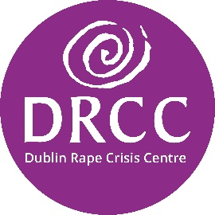

**Dublin Rape Crisis Donor Charter:**

**Our commitments to you**

# Our pledge is to treat all of our donors and prospective donors with respect, honesty and openness. We commit to being accountable and transparent so that donors and prospective donors can have full confidence in Dublin Rape Crisis Centre (DRCC).

We commit to our donors and prospective donors that:

* All fundraising will respect the rights and dignity of donors, beneficiaries and the public.
* Fundraising activities will not be unreasonably persistent, intrusive or place undue pressure on people to donate. Should someone not wish to donate, or wish to cease making a donation, that decision will be respected.
* Beneficiaries will not be presented in a disrespectful way in promotional activities and, where possible and appropriate, clients and beneficiaries will have an input into the promotional strategies of the charity.
* Fundraising will occur in an honest and truthful manner.
* Fundraisers will act with integrity and not misrepresent the charity, its need for funds or how they will be applied.
* Questions about fundraising activities and fundraising costs will be answered honestly and in a timely manner.
* Information about the charity’s charitable purpose and activities will be made freely available.
* Charitable donations and gifts will be used for the purposes for which they were donated
* Dublin Rape Crisis Centre will take responsibility for its actions and will be capable of explaining, clarifying and justifying those actions.
* Dublin Rape Crisis Centre’s trustees and management will explain and account to donors and the public for the charity’s actions.
* Dublin Rape Crisis Centre will operate in an open, frank and honest way and will ensure that transactions, operations, information and communications are easily understood by donors and the public alike.
* Dublin Rape Crisis Centre will clearly identify to donors and the public the cause for which the fundraising is occurring and how donations will and are being used.
* Dublin Rape Crisis Centre will provide ways whereby those interested can easily contact the charity.
* Dublin Rape Crisis Centre will have a procedure in place to address complaints.

What to do if you have feedback

If you have a query, any feedback, or a complaint about any aspect of our fundraising you can follow [Dublin Rape Crisis Centre’s Feedback and Complaints Policy for non-service users](https://www.drcc.ie/assets/files/pdf/drcc_comments_feedback_and_complaints_-_external_info__may_2021.pdf).