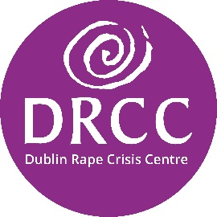DRCC’s Commitment to Fundraising Standards

Trustworthiness and respect are two of Dublin Rape Crisis Centre’s (DRCC) values and they are integral to how we operate as a charity. This includes how we raise funds, how we work with donors and prospective donors and how we spend the funds raised.

We aspire for all our donors to feel inspired by their involvement with DRCC. We want you to have complete trust that your donation(s) is being used to support of our charitable purpose and we hope that you enjoy being part of the DRCC family.

We are proud to commit to complying with the [Guidelines for Charitable Organisations on Fundraising from the Public.](https://www.charitiesregulator.ie/media/o5ul004d/guidance-for-fundraising-english.pdf)

You can read more about DRCC’s commitment to responsible fundraising via:

* Donor Charter
* Public Compliance Statement
* Feedback and Complaints Process for non-service users
* Annual Reports, which include annual audited accounts
* Charities Governance Code