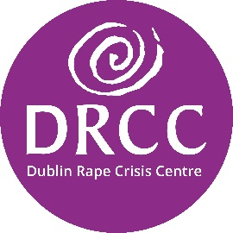**Public Compliance Statement**

Dublin Rape Crisis Centre (DRCC) is very proud of the generosity shown to the charity by donations from the public. We want to do you proud as well and as such we are committed to complying with the Guidelines for Charitable Organisations on Fundraising from the Public.

* The Board of Directors of DRCC has formally discussed and adopted the Guidelines
* DRCC confirms its commitment to the principles set out in the Guidelines by a statement to that effect in its annual report.
* DRCC has a Donor Charter which is consistent with the Guidelines
* DRCC provides honest, open and transparent disclosure when fundraising from the public
* DRCC regularly monitors compliance with the Guidelines; we consider the Guidelines when planning all fundraising activity and compliance reports are received regularly by the governing body
* The CEO of DRCC is responsible for compliance with the Guidelines and fundraising staff are provided with information and training on the Guidelines and its implementation
* DRCC has a feedback and complaints procedure consistent with the Guidelines; feedback is recorded for review by relevant staff including the CEO and governing body and is responded to promptly and appropriately
* DRCC prepares financial reports consistent with the requirements of the Charities Act 2009 and the Charities Regulator which include a statement concerning the extent to which control of the organisation is independent of its fundraising sources.
* DRCC ensures that all donations are recorded and comply with data protection requirements
* DRCC is accessible to the public through a number of readily available contact options

For further information: Click here for the Charities Regulator’s [Guidelines for Charitable Organisations on Fundraising from the Public](https://static1.squarespace.com/static/57ff6b30bebafba9d10c7dcd/t/59cb7acbc534a512723748a7/1506507479316/Guidelines+Charitable+Organisations+on+Fundraising.pdf) (2017)